[CONTEST] A new look for the 10th anniversary of the Federation
July 14, 2014 in Fédération
This year is an important year as we celebrate 10 years of the formation of our Federation. Ten years of development and evolution in which we have gone from 4 to 20 clubs! This growth could not have taken place without you the members and not without the countless volunteers who support our efforts to put a spotlight on our unique sport.
As part of the celebrations the FFG invites you to participate in the celebration by proposing a new logo. This will be done by a contest that we hope will stimulate your imagination. A jury will gather to choose from the submissions in order to select the proposition that best represents the image of the Federation. No limits to any creative idea that will direct the identity of the Federation for the next ten years (website, documents, website etc) The first official release of the logo will be on the 15th of November 2014 when a French national team will where the first national team jerseys, with of course the winning logo. In order to participate, we invite you to carefully read the directions below. It would be a pity to be disqualified because you missed one of the instructions.

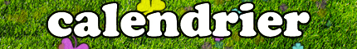
14 July 2014
opening of the competition

10 September 2014 (midnight)
end of entries
Any submission sent after this date will not be considered.

24 September 2014
End of jury consideration

28 September 2014
Publication of results

By participating in this competition, you accept to forfeit all rights of usage of your creation to the Fédération de Football Gaélique.
The number of entries per person is unlimited: a single participant can submit any number of propositions. The contest is open to the general public.
The complete entry must be addressed to concoursffg@lili-one.net, with the subject line “Concours de logo FFG”. The body of the message must contain the full name and email address of the particpant.
The entry will be examined by the secretary of the contest who will then distribute the images in an anonymous fashion to the members of the jury. This will maintain the impartiality of the jury.
The image must not appear on any public or social network (personal blog or website, Facebook, Twitter, etc) before the results of the contest are released. Once again this is to maintain the neutrality of the jury.
The members of the jury are not permitted to participate in the contest.
Any submissions that do not adhear to the above instructions will no longer be considered for the contest.
The legal and proper conduct of this contest is arbitrated by SCP Jean-Philippe GELÉ, Huissier de Justice Associé, domicilié 22 avenue de Limoges CS 78543 (79025) NIORT cedex.

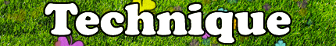
The submissions must be comprised of:
Technical considerations:
- An “.ESP” file (Photoshop) or “.AI” (Ilustrator) in CMJN format. A “.PSD” (Photoshop) format could be acceptable provided that the resolution is of at least 3000 x 3000px. Any other format cannot be admitted.
- An image in “.PNG” to evaluate an image of a maximum of 500 x 500px.
Le dossier technique doit comprendre :
- Un fichier .ESP (Photoshop) OU .AI (Illustrator) en mode CMJN de préférence. Un fichier .PSD (Photoshop) pourra être accepté à condition d’avoir une résolution minimale de 3000 x 3000 px. Tout autre support ne sera pas admis.
- Une image de présentation en .PNG afin de pouvoir juger les transparences, 500 x 500 px maximum.
Image requirements:
- « FFG » or « Fédération de Football Gaélique » must appear in the image.
- You must leave at least 5mm on the each of the four sides of your image.
- Fill colours in completely, avoid graduations in colour. If you wish to have degredations in colour please submit two images: one with and one without..
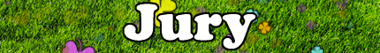
Aurelie Seiller
President of the FFG

Maël Duigou
President of the Ligue Bretonne

Magali Habert
Graphic designer

Guillaume Kerrien
Former President of the FFG

Brian Clerkin
PRO for the European County Board

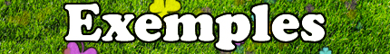
Need inspiration ? With or without rooster, with sport image or not, Blue-White-Red or not….We propose as well logos from other federations, don’t forget we also have members who participate in hurling and camogie….

